Software Requirements Specification

AA-UAV

Android Ar.Drone - Unmanned Aerial Vehicle

Release 1.0

Prepared by: Shmulik Melamed

Lital Motola

Table of Contents
Table of Contents ii
1. Introduction 1
1.1 Purpose 1
1.2 Project Scope and Product Features 1
2. Overall Description 1
2.1 Product Perspective 1
2.2 User Classes and Characteristics 1+2
2.3 Operating Environment 3
2.4 Design and Implementation Constraints 3
2.5 User Documentation 3
2.6 Assumptions and Dependencies 3
3. System Features 4
3.1 Free Flight 4
4. External Interface Requirements 5
4.1 User Interfaces 5
4.2 Hardware Interfaces 5
4.3 Software Interfaces 5
4.4 Communications Interfaces 5
5. Other Nonfunctional Requirements 6
5.1 Performance Requirements 6
5.2 Security Requirements 6
5.3 Software Quality Attributes 6
Appendix A: Data Dictionary and Data Model 7
Appendix B: Analysis Models 8

Introduction

Purpose
This SRS describes the software functional and nonfunctional requirements for release 1.0 of the AA-UAV application. This document is intended to be used by the members of the project team that will implement and verify the correct functioning of the system. Unless otherwise noted, all requirements specified here are high priority and committed for release 1.0.

Project Scope and Product Features
AA-UAV is a new AR.Drone Android Application that transforms the AR.Drone to a mini UAV meaning we can fly it further and higher, we can tell him to fly alone and we can get more information about the flight in real time.

Overall Description

Product Perspective
The AA-UAV application is a new system that upgrades the current communication from Wi-Fi to cellular and implements more features, such as: data on real time, auto navigation track. The context diagram in Figure 1 illustrates the external entities and system interfaces for release 1.0. The system is expected to evolve over several releases.

User Classes and Characteristics

The users are peoples that like to fly a plane. Their age is vast: from young to old.

The application purpose is to allow the police or factories to use the AA-UAV as part of their security system, therefor the Police and Factories are the main users.

Police – the police can use the AA-UAV to trace bad people in real time from every ware.

Factories – use the AA-UAV to secure the factory by setting a track and let him fly alone and
Video tape anything around the factory.

The future application will also be able to share data and video between the planes and use those functionalities for real time gaming.

Users – Two users can take two planes set a destination point in the map and then start a race
between the planes, each user can see the movement of the two planes in real time.

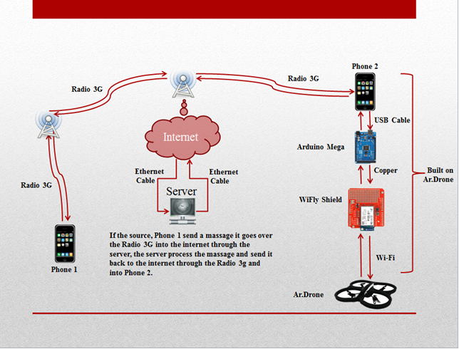

Figure 1
Context diagram for release 1.0 of the AA-UAV System.

Operating Environment
OE-1: The AA-UAV App server & user will work on the Android Phone Operation System with API 16 and above.
OE-2: The AA_UAV Main server will work on a simple computer with a windows operation system.
OE-3: The AA-UAV web application will work on Chrome, and Firefox Browsers.

Design and Implementation Constraints
CO-1: The server & user system shall use the current android API engine.
CO-2: The Main server system shall use the latest eclipse classic.
CO-3: All HTML code shall conform to the HTML 5.0, JQuery, Ajax and MySQL Standards.

User Documentation
UD-1: The user application provides help button that describes and illustrates all system functions.
UD-2: The website provides help button that describes and illustrates all the website functions.
The website provides help guide for how to start the first flight from the beginning.

Assumptions and Dependencies
AS-1: Bad Wheatear is not a god day to fly the plane.
DE-1: Two phones running Android API 16 or above.
DE-2: The flight will take place only where there is a cellular antenna and only after
the connection between server-client succeed.

System Features

Free Flight

3.1.1 Description and Priority
A user can use the free flight feature to establish points in a map and give the plane a command to flay alone from one point to another.

3.1.2 Stimulus/Response Sequences
Stimulus: User clicks on the map sign in the application.
Response: Server gets a request for the current place of the plane.
Stimulus: Plane application gets a request for the plane current place and the plane application response with the GPS plane position.
Response: Server gets the response from the plane application and sends it as response to the user application.
Stimulus: User get the response and given the option to choose another point on the map, when finished the user press on fly alone that sends a request to the server.
Response: the server gets the request to fly alone and send the command to the plane application and a response that he did it to the user application.

External Interface Requirements

User Interfaces
UI-1: Plane application- After the server application started, the user can start the plane application on the android device and press on 'Connect' button. Then the user will get a message that it connected to the plane application and to the server application. If there is a problem and it couldn't connect the user will get a message that there is a problem with the connection and a message about what seems to be the problem
UI-2: User application- control the AR.Drone by Left Pad & Right Pad, information about the flight (such as: altitude and longitude).
UI-3: Computer application- website- information about the flight.

Hardware Interfaces
ADK – Arduino mega for communicate with the phone.
Wifly Shield – communication with the plane.

Software Interfaces
SI-1: Plane Application
SI-1.1: Check connection to all devices.
SI-1.2: Check connection to the server.
SI-1.3: Massage to the user if there is a problem or if the connection is ok.

SI-2: User Application
SI-2.1: Check connection to all devices.
SI-2.2: Check connection to the server.
SI-2.3: Massage to the user if there is a problem or if the connection is ok.
SI-2.4: Controlling the plane in real time.
SI-2.5: Setting a track from point A to point B on the map for auto flight.
SI-2.6: Flight real time information.

SI-3: Server Application
SI-3.1: Printing the information coming from the plane and user applications.
SI-3.2: Handling the information coming from the plane and user applications.

Communications Interfaces
CI-1: The server sends massages to the Application telling them about the communication status.
CI-2: The Applications sends massages to the server about actions information and connectivity status.

Other Nonfunctional Requirements

Performance Requirements
PE-1: The plane has to be connected to a WiFly Shield and Arduino mega.
PE-2: The server has to working at all time.
PE-3: Massages between the user and plane application must receive in no more than 5 seconds.

Security Requirements
SE-1: If the connection to the plane is gone for 15 seconds, then the plane application take control and find a place to land it.
SE-2: If the battery of the plane or phone or arduino is low then the plane application land the plane in safe place.
SE-3: If the weather is not suite for flying then the plane does not fly.
SE-4: If the plane is on auto flight and the weather in the way is not suite for flying then the plane application find another way in good weather to reach the destination.
SE-5: If there is an object in front of the plane then the plane finds a way get around that object.

Software Quality Attributes
Availability-1: The AA-UAV system is available at all time as long as the server is up and running. (Applications available to be downloaded at all time from the android application store).
Robustness-1: If the connection between the user and the plane is broken, the plane application enables the auto emergency flight and tries to recover the connection.

Appendix A: Data Dictionary and Data Model

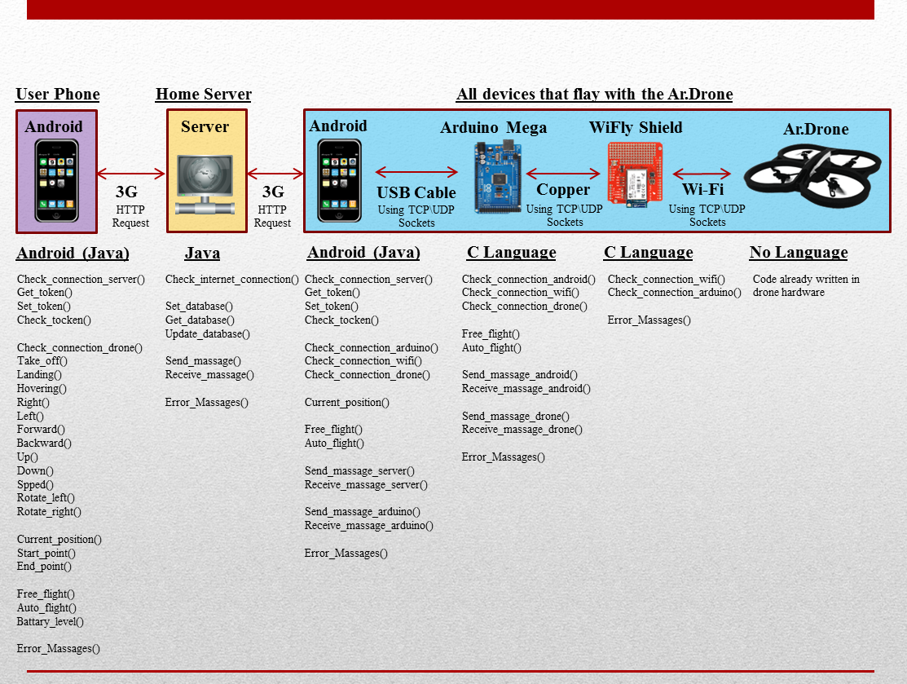
Figure 2
Context diagram for release 1.0 of the AA-UAV System.

Appendix B: Analysis Models

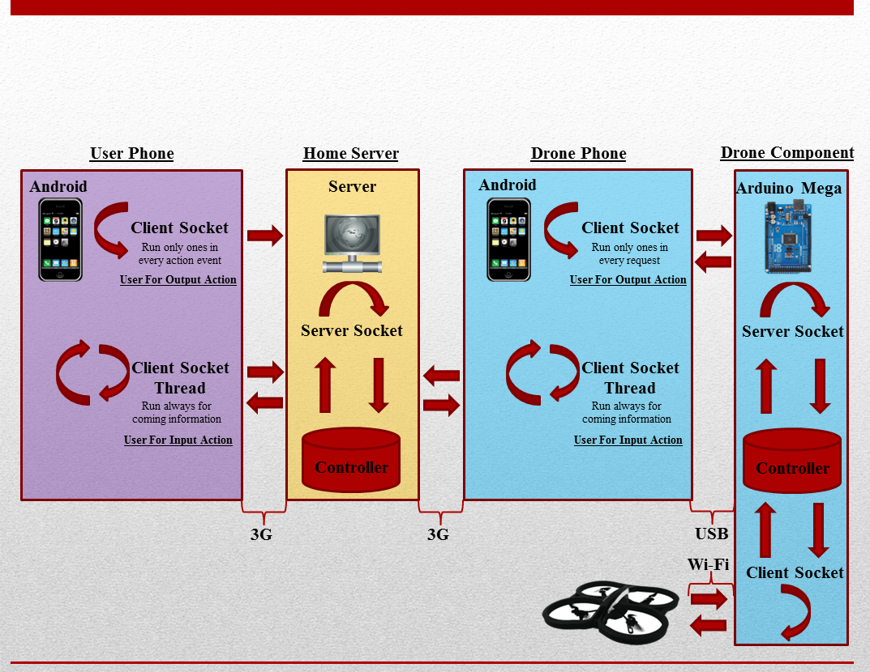
Figure 3
State-transition diagram for connection status.

